Andrew Dykman – Business Concepts for Application Developers – Lab 3 – 7/25/2012

Task 1, Question 2.)

Question 1.) Customer Relationship Management Software, Production Management Software, Accounting Management Software

Question 2.) The 'Quantity over Quality' business model with automation through information management systems.

Question 3.) JetBlue's problems began with pushing quantity over quality by making assumptions to keep production going when other companies knew they were in a situation where production should have been halted, in this case not flying because of weather being bad that day. Information systems were also involved, because after the incident they were not able to help speed recovery due to the inflexibility of being completely automated, and a system was not in place for JetBlue employees to have their assignments rerouted and have their planes redeployed in a timely fashion.

Question 4.) JetBlue created a customer “bill of rights” to ensure that customers were fairly treated and employees / the company itself was reprimanded when customer expectations were not met as was the case in this scenario.

Extra Assignment Question.) The problems that are likely to re-occur is that JetBlue's response did not upgrade and / or fix the information systems that created the complications after the incident. They simply created a “bill of rights” and vowed to pause production after the incident. Should they forget this incident, and resume pushing production when it should be halted they will run into a similar problem again.

Task 2.) (Slideshow and Narrative)
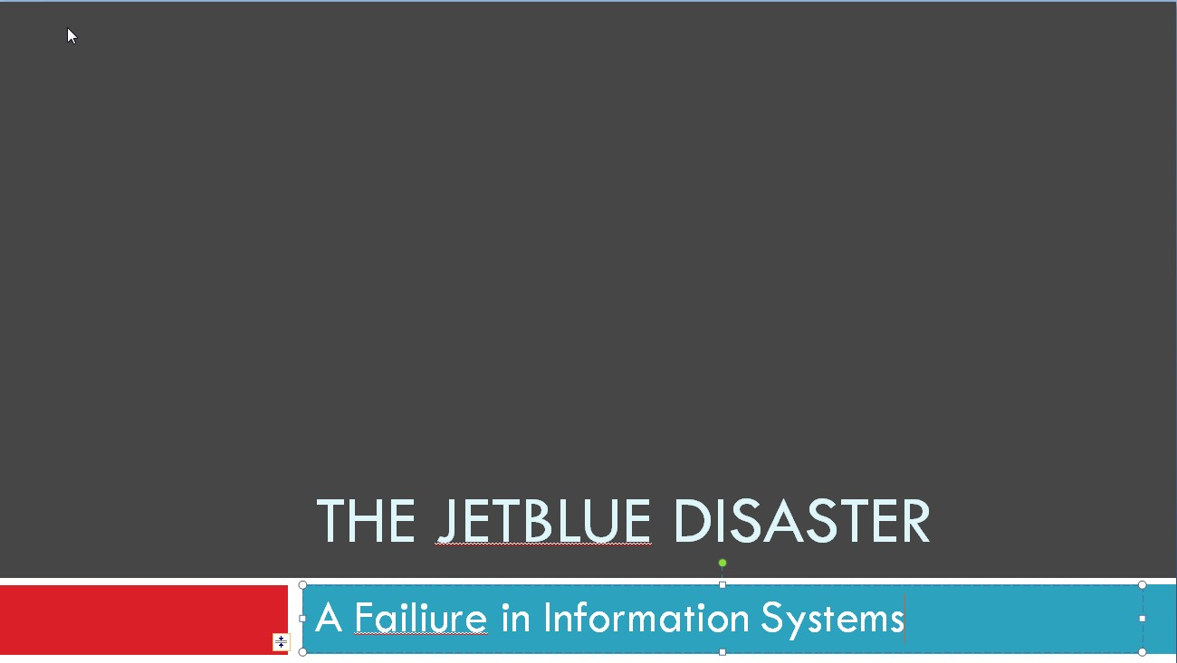

You don't need to be a frequent flier to know that the friendly skies aren't so friendly anymore.
Cramped, overloaded planes, flight delays, and bare-bones amenities are the norm on most of the legacy carriers. But low-cost airlines like Southwest and JetBlue have found opportunity in the misery, and captured more of the market, with competitive fares, friendly service, and in the case of JetBlue, leather seats with television.
Founded in 1999, JetBlue has seen rapid growth and frequently tops annual customer surveys of their favorite airlines. But on a Valentine's Day to remember (or forget) all that changed.
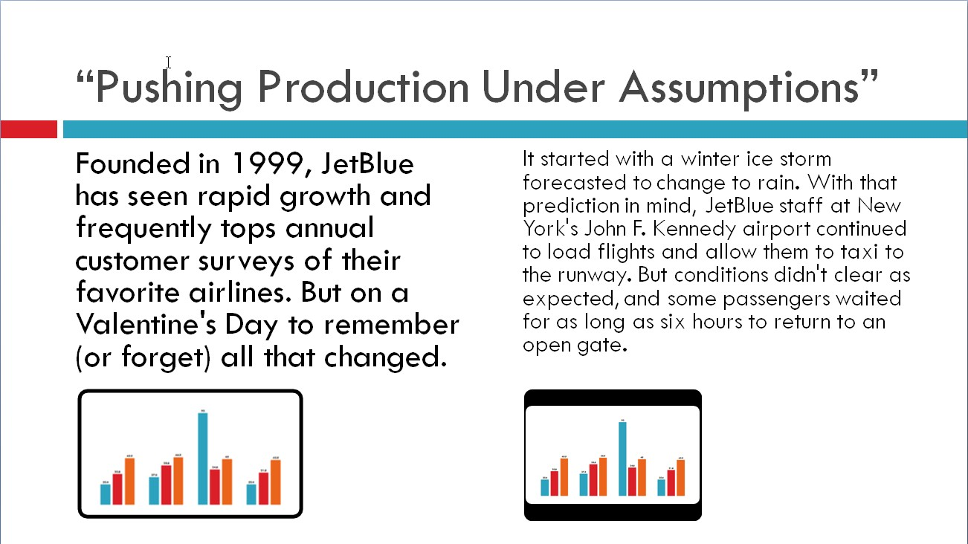

It started with a winter ice storm forecasted to change to rain. With that prediction in mind, JetBlue staff at New York's John F. Kennedy airport continued to load flights and allow them to taxi to the runway. But conditions didn't clear as expected, and some passengers waited for as long as six hours to return to an open gate. (Planes continued to land in the poor weather; but FAA regulations regarding icy conditions prevented flights from taking off.)
That day, only seventeen of JetBlue's 156 scheduled departures left JFK, a fact that caused ripple effects throughout the system and displaced crew and aircraft. In subsequent days, JetBlue management canceled more and more flights, angering thousands of passengers, until finally, on February 20, normal operations resumed.
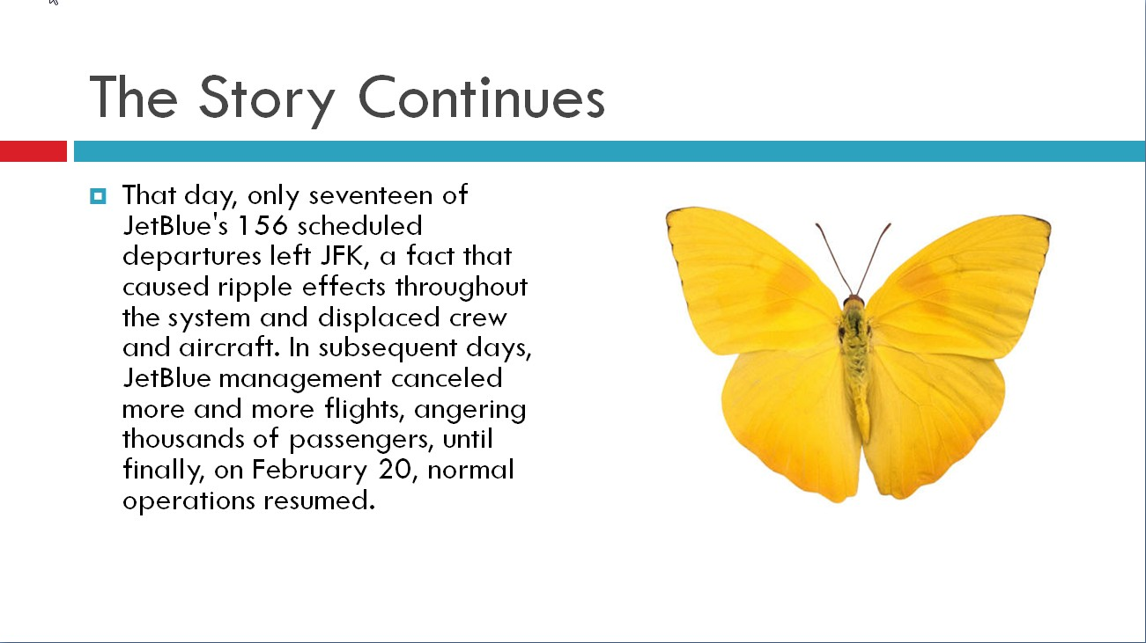
This was such a dramatic operating event for the airline that it's hard not to think there's more than just an accident happening here, and now that you suspect this, how do you react as a manager? How do you restore confidence among your customers?"

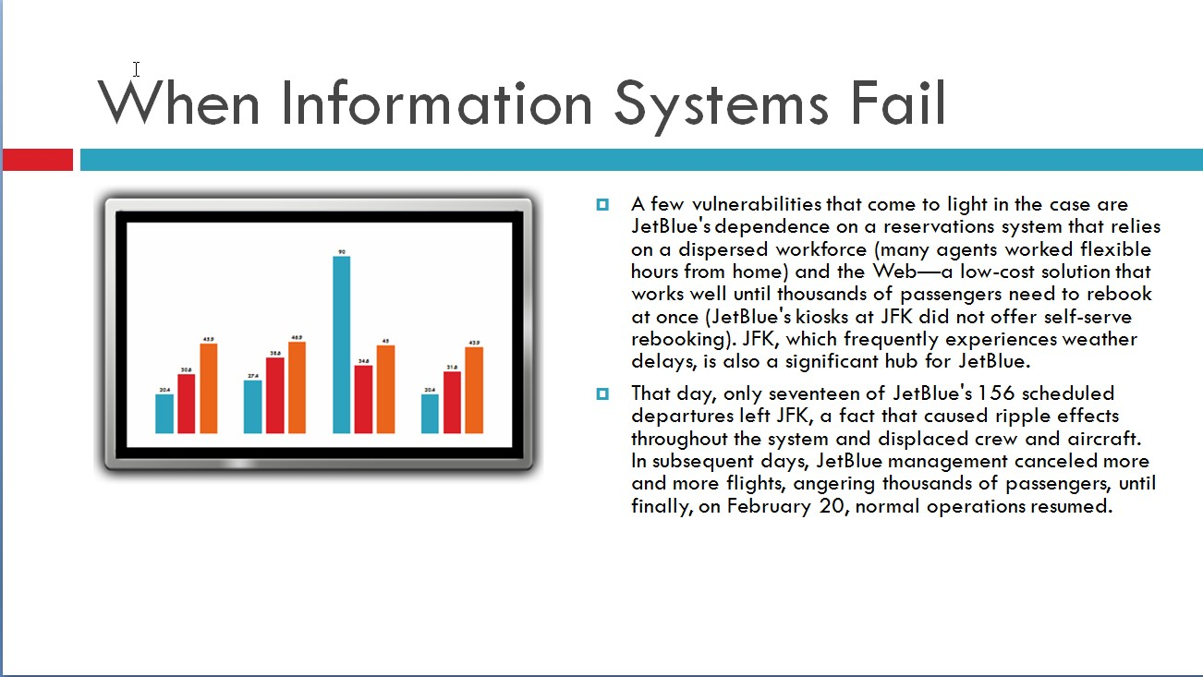

"The real questions to ask here are about evaluating JetBlue's operating system as of February 13, independent of this event. Do we think the elements of the structure and systems within the JetBlue operation are internally consistent with one another and externally consistent with the organization's overall business strategy?”

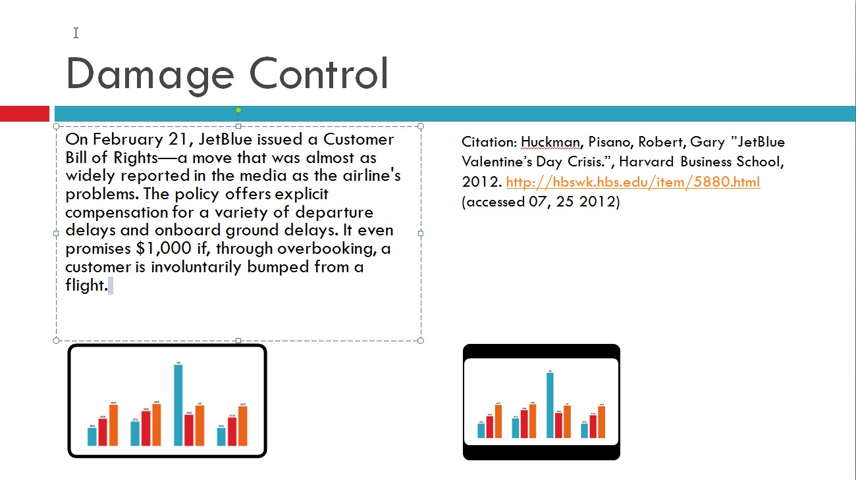
"Given JetBlue's strong reputation as a service-oriented airline, one of the issues students wrestle with is whether or not the airline needed to be this specific in how the penalties and compensation would work," it leaves the feeling JetBlue could have traded on its good reputation and simply apologized without creating such a specific document.
Citation: Huckman, Pisano, Robert, Gary ”JetBlue Valentine’s Day Crisis.”, Harvard Business School, 2012. http://hbswk.hbs.edu/item/5880.html (accessed 07, 25 2012)

